Eventbrite Best Practices

Audience: Outreach leaders interested in simplifying the registration process for events.

Objective/Intended Use: Successful outreach events can take many forms. For the purposes of this document, we will demonstrate how to set up event registration for two parallel programs or tracks (one for students and one for Parents and educators). We encourage you to modify the registration set up to fit your needs.
- While you can use Eventbrite to register volunteers or speakers, a resource like www.volunteerlocal.com is better suited for that. We strongly recommend using volunteer local when you have a large group of volunteers and are assigning multiple shifts.
Contents
Eventbrite Best Practices 1
What is Eventbrite? 2
Get Started! 2
Create an Event 3
Create Tickets 4
Manage Event 5
Order Form – Attendee tab 6
Preview Event 7
Society of Women Engineers (SWE) Permission Form for Minors 8
Appendix B 9
Student and Parent/Educator Program Track Acknowledgement 9
Appendix C 10
Minor Photo/Video Release Waiver 10
Appendix D 11
Adult Photo/Video Release Waiver 11

Resources:
- Account with Eventbrite - https://www.eventbrite.com/
- Social media promotion tools
- Tracking participation

What is Eventbrite?
- Eventbrite is a website that event organizers use to sell tickets (free and for a price) and provide online registrations for various types of events. It is ‘self-service,’ which means that Eventbrite provides tools for organizers to promote their events using multiple social media tools with tracking links and affiliate programs.
- Eventbrite can also be accessed on your mobile.
- We encourage you to watch this video to learn more about Eventbrite.
- There are no upfront costs. There is no charge if your tickets are free. Eventbrite will take a small percentage of your ticket sales if you do charge.

Get Started!
Register to use the site:
  - Select the following link to access Eventbrite. https://www.eventbrite.com/
  - Select Sign Up to create your account.
  - Enter your email address and a password and select Sign up.

Create an Event
The first step is to create your event and provide the basic event logistics such as title of the event, location, date and time, description, the organizer name and bio, and create the ticket that can be purchased. Complete the following steps to create your event and tickets.
Event Details:
1.Select Create Event
- Please note the section to Save, Preview, and Make Event Live.
- Enter a catchy descriptive Title. | 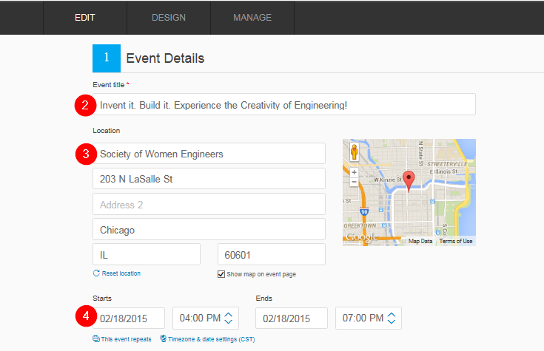
- Enter a Location – you can also select to show a map on the event registration page.
- Enter Start and End time.
- Add a creative and dynamic photo using the Event Logo option using Select File.  Note: you must have a file saved in order to upload it. | 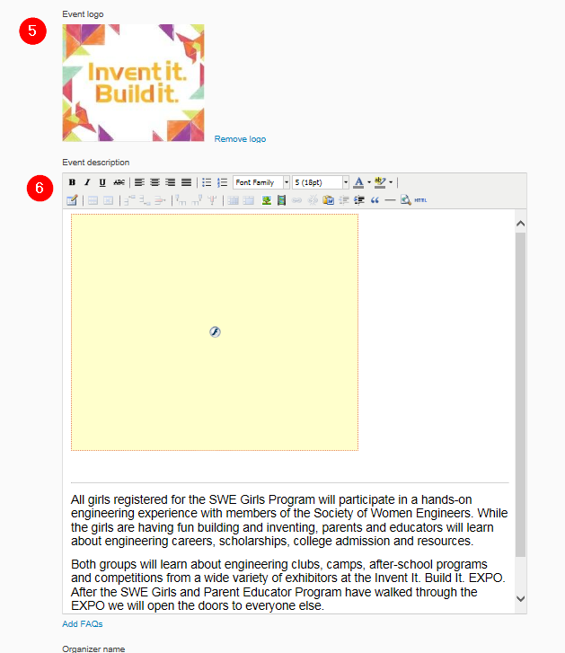
- Add an Event Description – a good description is what gets people excited. Consider the following:
  - What is special about the event?
  - Why the event is relevant?
  - What new knowledge, resources, etc. will attendees leave the event with?
  - Also include any pertinent details that attendees should be aware of.
- Add the Organizer’s name. | 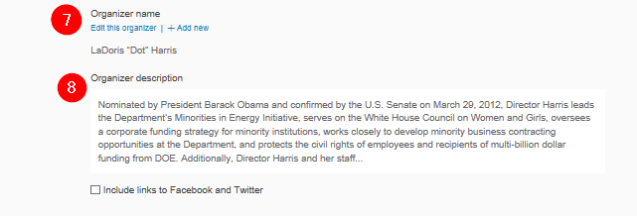
- Enter an Organizer description - Be enthusiastic and illustrate your interest in the event.

Create Tickets
In Eventbrite it helps to think of each registration as a ticket sale (whether free or not). As mentioned above, we are demonstrating what an event would look like with a track for students and a track for parents and educators. Two tracks, means two ticket types. How many ticket types you create depends on your event.

Here’s how to create the ticket types for your event. Please note that you will need to go through the steps below for each ticket type that is needed. For example, if there are two separate programs (students and parents/educators), you will need to create two tickets. If girls and parent/educators are all participating in the same program, only one ticket is needed.
- Select Free ticket or Paid Ticket – Paid tickets are recommended because the participants are more likely to attend the event if there is some money involved. A nominal fee is usually charged. Somewhere between $5-10. Be sure to offer a promo code for those that cannot afford the fee. | 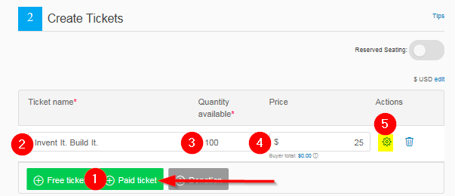
- Enter the Ticket name – be sure to include STUDENT in the name for student tickets and PARENT/EDUCATOR in the name for Parent / Educator Program (PEP) participants.
- Enter the Quantity of tickets that will be available.
- Enter Price of ticket if applicable.
- Select Settings for additional ticket options.
Settings Options:  - Enter Ticket description if needed and select Show ticket description on event page. | 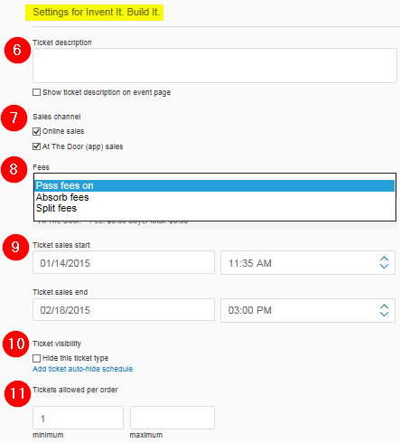
- Select Sales channel available for your event (Online sales and/or At the Door (app) sales).

- For Paid Tickets, select how you would like the Eventbrite Payment Processing fee to be handled. Refer to this video to learn more.
- Enter Ticket sales start and end dates and times.
- Ticket visibility – check “Hide this ticket type” based on availability or for a certain period of time.
- Enter the minimum and maximum number of tickets allowed per order.
Additional Settings:  - Listing privacy – Select Public page to make your event appear in the Eventbrite listings.  - To show the Remaining tickets, select “show the number of tickets remaining on the registration page”. | 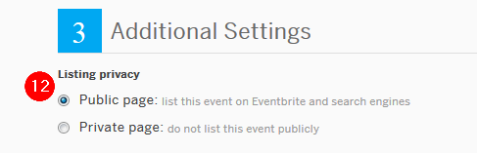  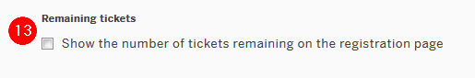
- Select Save or Choose a Design to select a theme for the event. Do not make your event live yet because you need to enter event details which will be covered next. | 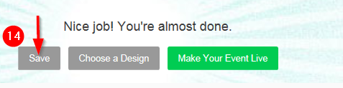

Manage Event
Eventbrite offers multiple categories and options to manage your event and the information about attendees. Below are options that SWE recommends using for your events. To “manage” your event:
- Select Manage from the top toolbar.
- Select Order Form from the left toolbar.
- Select the Basic Information tab which includes basic information for managing your event.
From the Registration Options, SWE recommends the following fields:
- Allow attendees to edit information after they have registered.
- Accept refund requests.
- Select Save.
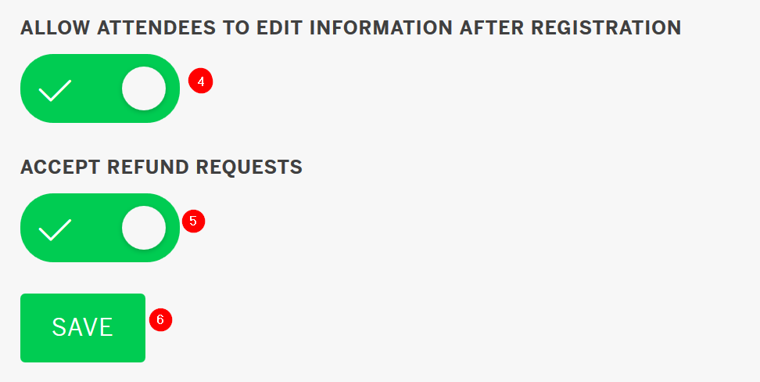

Order Form – Attendee tab
Registration data will need to be completed for both students and parents or educators. To ensure you are viewing the correct data, make sure the appropriate “Collect information by ticket type” is selected. You should have created a ticket type for both which will appear as options.
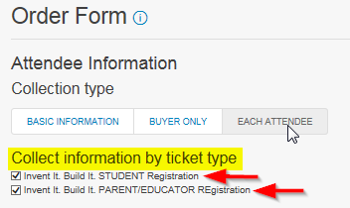
Notice the editable columns that can be selected to “Include” and/or “Require” to complete when participants are registering for your event.
- Include the Information to collect by selecting the button. It will turn green when selected.
- Select the Required button to make the question required.
- SWE recommends the following:
Complete for Student | Recommended Information to Collect | Parent or Educator | Special Notes
X | First Name | X
X | First Name | X
X | Last Name | X
X | Email Address | X
X | Home Phone | X
X | Cell Phone | X
X | Billing Address | X
X | Credit Card Info | X | Required in order to make payment.
X | Home Address | X
- To create additional questions, select create a question.
- Below are additional recommendations to assist with managing your event. Recommendations for student and parent/educator (PEP) registration are provided. Feel free to modify this list to meet your needs.
Student | Questions Prompts | PEP | Question Type | Special Notes
X | Gender of participant | X | Radio Buttons
X | Student’s Grade (this school year) |  | Dropdown | Enter the grade options for the event.
X | Student’s Age ( as of event date) |  | Dropdown | Enter age options
X | Please list any participant food allergies or dietary restriction | X | Paragraph Text | Optional settings: select the appropriate ticket type this question is appropriate for.
X | Name of student’s school (write “home school” if that is the case) |  | Text | Optional settings: select the appropriate ticket type for this question.
X | Demographic that best describes the participant | X | Dropdown | Examples: Native Hawaiian/Pacific Islander, American Indian/Alaska Native, Black/African American, Hispanic/Latino, White, non-Hispanic, Two or more races.
X | How did you hear about this event? | X | Dropdown | Examples: teacher/school, SWE member, religious group, Girl Scouts, Girls Inc., friend/family, Internet, other.
X | Society of Women Engineers (SWE) Permission Slip and Release and Waiver Form for Minors |  | Waiver | Refer to appendix A.
X | Student and Parent/Educator Program Track Acknowledgement | X | Waiver | Refer to appendix B.
X | Minor Photo/Video Release Waiver |  | Waiver | Refer to appendix C.
 | Adult Photo Release Form | X | Waiver | Refer to appendix D.
X | What is your t-shirt size? | X | Dropdown | ONLY if providing t-shirts at your event.
X | If special assistance is required to fully participate in the event, please explain, otherwise leave blank | X | Paragraph Text
X | I would like SWE to stay in touch with me about other events like this | X | Dropdown | Options: Yes, No
X | Provide name and phone number of an emergency contact. If this contact is the same person as the ticket purchaser, simply write “same” | X | Paragraph Text
X | What is your goal in attending | X | Paragraph
X | IF a meal will be provided, list food options to select from | X | Radio Button | It is recommended to include an option for “I will bring my own”.
 | Which best describes you | X | Dropdown | Possible examples include: mother, father, educator, group leader, guardian, and media.

Preview Event
Once you have completed the appropriate fields, it is recommended that you preview your event prior to publishing it live by selecting Preview at the top of your screen. 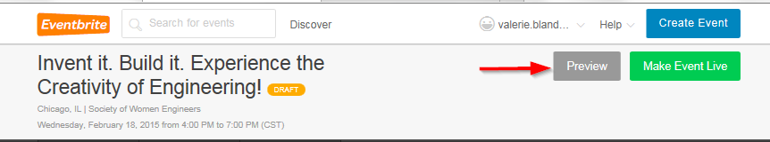
Appendix A

Society of Women Engineers (SWE) Permission Form for Minors
As his or her parent or legal guardian, I hereby give permission for this ticket holder to attend and participate in the Society of Women Engineer’s (SWE) Outreach event. I acknowledge that activities will include working with materials and equipment. I understand and assume all possible risks involved. I hereby release SWE and others working for SWE or on its behalf from responsibility and liability for any illness or injury that my child may sustain during this event. Permission is also given for my child to ride in any vehicle designated by the school or adult leader of this event. In the event of an emergency, I hereby authorize an adult leader of this event as agent for me, to consent to any medical or dental examination or diagnosis, treatment, or hospital care advised and supervised by a physician, surgeon, dentist (as appropriate).

The ticket holder is in good health and is at or above the minimum age of 10. I understand that physical exertion may be required, and my child has no known disabilities or health problems which will present any risk to his/her participation in the activities.

Appendix B

Student and Parent/Educator Program Track Acknowledgement
I acknowledge that The Parent /Educator program is separate from the student program. I understand that I will not be working with the students throughout the day.

If a student has special needs that require an adult to be with that student, I acknowledge that I have contacted the event organizers and made those arrangements.

Appendix C

Minor Photo/Video Release Waiver

For good and valuable consideration, the receipt and sufficiency of which are hereby acknowledged, I hereby consent and agree to the following:

1. I hereby grant to Society of Women Engineers (SWE), and others working for SWE or on their behalf, and each of its respective licensees, successors and assigns (each a “Release”), the irrevocable, royalty-free, perpetual, unlimited right and permission to use, distribute, publish, exhibit, digitize, broadcast, display, modify, create derivative works of, reproduce or otherwise exploit my name, picture, likeness and voice (including any video footage of the same) (collectively, “Media”), or to refrain from so doing, anywhere in the world, by any persons or entities deemed appropriate by SWE, for any purpose including, without limitation, any use for educational, advertising, non-commercial or commercial purposes in any manner or media whatsoever (whether known or hereafter devised) including, without limitation, on the internet, in print campaigns, in-store and via television. I agree that I have no interest or ownership in any of the Media.

2. I shall have no right of approval, no claim to compensation and no claim (including, without limitation, claims based upon invasion of privacy, defamation or right of publicity) arising out of any use, alteration, blurring, illusionary effect or use in any composite form of my name, picture, likeness and voice. I agree that nothing in this Release will create any obligation on SWE to make any use of the Media or the rights granted in this Release. I hereby release and hold harmless Releases from any claim for injury, compensation or negligence resulting or arising from any activities authorized by this Release and any use of the Media by SWE.

Appendix D

Adult Photo/Video Release Waiver

For good and valuable consideration, the receipt and sufficiency of which are hereby acknowledged, I hereby consent and agree to the following:

1. I acknowledge that I am eighteen (18) years of age or older. I hereby grant Society of Women Engineers (SWE), and others working for SWE or on their behalf, and each of its respective licensees, successors and assigns (each a “Release”), the irrevocable, royalty-free, perpetual, unlimited right and permission to use, distribute, publish, exhibit, digitize, broadcast, display, modify, create derivative works of, reproduce or otherwise exploit my name, picture, likeness and voice (including any video footage of the same) (collectively, “Media”), or to refrain from so doing, anywhere in the world, by any persons or entities deemed appropriate by SWE for any purpose including, without limitation, any use for educational, advertising, non-commercial or commercial purposes in any manner or media whatsoever (whether known or hereafter devised) including, without limitation, on the internet, in print campaigns, in-store and via television. I agree that I have no interest or ownership in any of the Media.

2. I shall have no right of approval, no claim to compensation and no claim (including, without limitation, claims based upon invasion of privacy, defamation or right of publicity) arising out of any use, alteration, blurring, illusionary effect or use in any composite form of my name, picture, likeness and voice. I agree that nothing in this Release will create any obligation on SWE to make any use of the Media or the rights granted in this Release. I hereby release and hold harmless Releases from any claim for injury, compensation or negligence resulting or arising from any activities authorized by this Release and any use of the Media by SWE.

