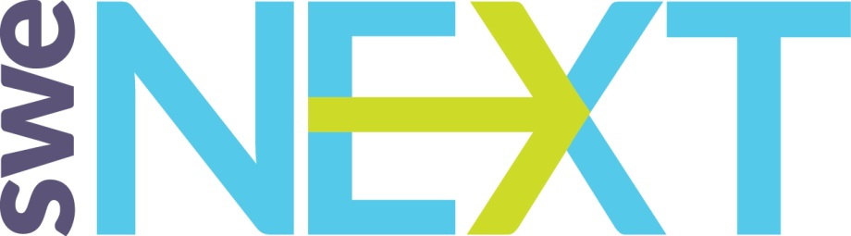

SWE Member Guide to SWENext!
  - Version 1.0

What is SWENext?
SWENext is a program for pre-college aged students who want to be a part of SWE. The cost to join is free. There are also memberships for families and educators to provide access to resources and information. SWENext is in the growing stages and will be developing over the next several years. Currently, SWENext provides scholarship information, awards, at-home engineering activities, SWENext Club resources, mentoring, and more.

Who can join SWENext?
Students ages 13-18 can join anytime. Students under 13 require a parent or guardian’s contact to join. Families, educators, and SWE members can join the SWENext mailing list to get more information.

What can SWE Members Do?

Promote SWENext
SWENext Flyer: SWE has created a SWENext flyer. The flyer can be found from the main SWENext page. There are several versions of the flyer that can be used. The first is a full-page flyer that you are welcome to use for displays, handouts, or to provide schools to hang in popular areas or hand out to the girls. This flyer is full color and contains pictures. The second version is called the “mini version”. This version was intended to be used as handouts at events like Science Fairs, a SWE booths, and at outreach events. The download provides four versions of the mini flyer:
Table 1 SWENext Handout Mini Flyers
File Name | Description | Preview and file*
16-SWE-011 SWE NEXT flyer half and quarter page color 2_3_16CP.pdf | Color version with choice of 2 per page or 4 per page
16-SWE-011 SWE NEXT flyer half and quarter page color 2_3_16CP.pdf | Printer friendly color version: with choice of 2 per page or 4 per page and NO pictures
16-SWE-011 SWE NEXT flyer half and quarter page bw 2_3_16CP.pdf | Black and white version with choice of 2 per page or 4 per page
16-SWE-011 SWE NEXT flyer half and quarter page bw NO images 2_11_16CP.pdf | Printer friendly version: Black and white version with choice of 2 per page or 4 per page and NO pictures
*Previews are for preview only and not intended to be used as flyers, please double click on the preview image to open the embedded file or visit swenext.swe.org to download the files.

Outreach Events
One of the biggest impacts SWE members can have on SWENexter is to host outreach events and now SWE can help make them an even bigger success by allowing SWE members to advertise events to SWENexters in their area! To advertise your event to SWENexters do the following:
- Visit the following link under K-12 Outreach - > SWE Member Resources and fill out the form: http://societyofwomenengineers.swe.org/page/5147-swenext-events
- SWENexters within the provided area will receive information about your event.
Tip: Want to know if SWENext worked as an advertising means? Add a field on your registration form of where they heard about the event. Consider offering a discounted rate to SWENexters if your event has a fee and provide the code in the email to SWENexters.

SWENext Clubs
We have seen a high interest from SWENexters in starting clubs at their schools. In order to start a club SWENexters require a SWENext Club Advisor. The advisor must be a SWE member.

Become a mentor

How to talk about SWENext
Below are some scenarios you may encounter at outreach events and some helpful tips to help you talk about SWENext.

Judging at in-person Science Fairs
Hand flyer to girl or parent and say: “We loved hearing about your project and hope you pursue engineering in your future. Here is some information about a program where you can join Society of Women Engineers today and have access to things like activities, scholarships, awards, and connect to SWE members. Good Luck in the science fair!”

Short Pitch at a booth or outreach event
Hand flyer to girl or parent and say “Here is some information about a program where you can join Society of Women Engineers today and have access to things like activities, scholarships, awards, and connect to SWE members.”

Speaking to large group at outreach event
Provide flyers in center of tables ahead of the event or in their goodie bags. “We wanted to tell you all about a great program called SWENext that is a way for you to be a part of SWE now. The program provides access to scholarships, awards, activities, upcoming SWE events in your area, and connection to SWE members. There is a flyer in <location of flyer> with more information and the SWENext website where you can sign up. We look forward to being a part of your journey into becoming engineers.”

