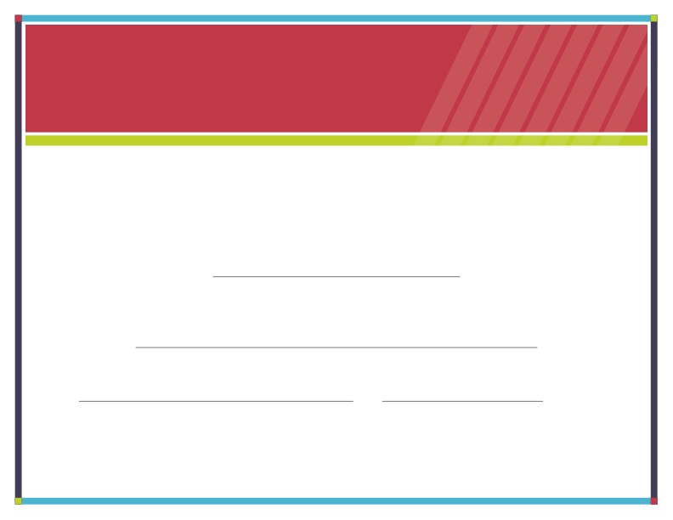

**Date**

**Signature**

**Has successfully completed**

**This is to certify that**

**Certificate of Completion**

Place official section logo here

**{Enter Date}**

**{Enter Program/Course}**

**{Enter Recipient Name}**

**{Enter Program Name}**