SWE COMMITTEE SPEAKING PROPOSAL
  - Please email this completed form to learning@swe.org for review and approval.

Thank you for your interest in presenting a learning course/program with SWE! SWE has over 100 professional development programs available in the SWE Advance Learning Center. The content is reviewed annually to determine content relevancy and need.
Instructions: If you are interested in presenting, complete each section below. SWE will notify you if the proposal has been accepted. Since SWE HQ is hosting the event, the SWE branded PPT must be used in addition to following the SWE brand guidelines.
* SWE committee webinar attendance policy: To allow for the most efficient use of HQ staff and committee leader time, the live webinar may be cancelled if it does not have 35 or more registrations two days prior to the live webinar date. If the live webinar is cancelled, committee leaders have the option to record the webinar offline and release it as an on-demand webinar to be hosted in the Advance Learning Center.

Section 1: Webinar Date & Logistics
- Do you want this placed into the SWE’s Advance Learning Center? ☐Yes ☐No

- Event time and date preference (1):
Click or tap here to enter text.
- Event time and date preference (2):
Click or tap here to enter text.
Please see Advance calendar for available dates.
- Time: Select the time needed to present the content keeping in mind the that a 60-minute webinar does not equal webinar success.
☐15-20 min. ☐30 min. ☐30-45 min. ☐60 min.
Section 2: Speaker Information
- Speaker (1) Name: Click or tap here to enter text.
- Organization: Click or tap here to enter text.
- Speaker email: Click or tap here to enter text.
- Short speaker bio: Click or tap here to enter text.
Section 3: Title, Description & Learning Outcomes
PROPOSED TITLE: Titles should capture interest and illustrate the benefit of attending.
Click or tap here to enter text.
DESCRIPTION: Provide a brief overview illustrating the benefits of attending the event.
Click or tap here to enter text.

LEARNING OUTCOMES: Learning outcomes describe how participants will be able to apply the information from your session to their jobs, career planning, SWE leadership, etc. Learning outcomes are evaluated based on whether they are (1) clearly stated and (2) achievable with instruction.
- Learning Outcome (1): Click or tap here to enter text.
- Learning Outcome (2): Click or tap here to enter text.
- Learning Outcome (3): Click or tap here to enter text.
Section 4: Track - Select the most appropriate track
☐Career Management
☐Inclusion & Cultural Awareness
☐Innovation & Disruption
☐Self-Management & Development
☐Strategic Leadership

Section 5: Specialized Area of Focus
☐Entrepreneurship
☐Outreach
☐STEM Re-Entry
☐SWE Leadership
☐Women in Academia
☐Women in Government & Military
Section 6: Target Audience
☐Collegians & Graduate Students
☐Entry-Level Professionals
☐Mid-Level Professionals
☐Senior Leaders & Executives
☐Retired

Section 7: Q&A - Provide 2-3 post learning questions to begin the Q&A portion of the event.
- Click or tap here to enter text.
- Click or tap here to enter text.
- Click or tap here to enter text.

Section 8: Referred delivery method keeping in mind SWE’s multigenerational membership.
☐Self-directed eLearning module |  | ☐Lunch & learn webcast |  | ☐Webcast
☐Live event w/ CEUs |  | ☐Podcast |  | ☐Web Seminar w/ CEUs
☐Live event w/out CEUs |  | ☐Lessons from the Field (case studies)
☐Other – Click or tap here to enter text.
Please note that if CEUs are provided, you must follow the IACET accreditation standards.

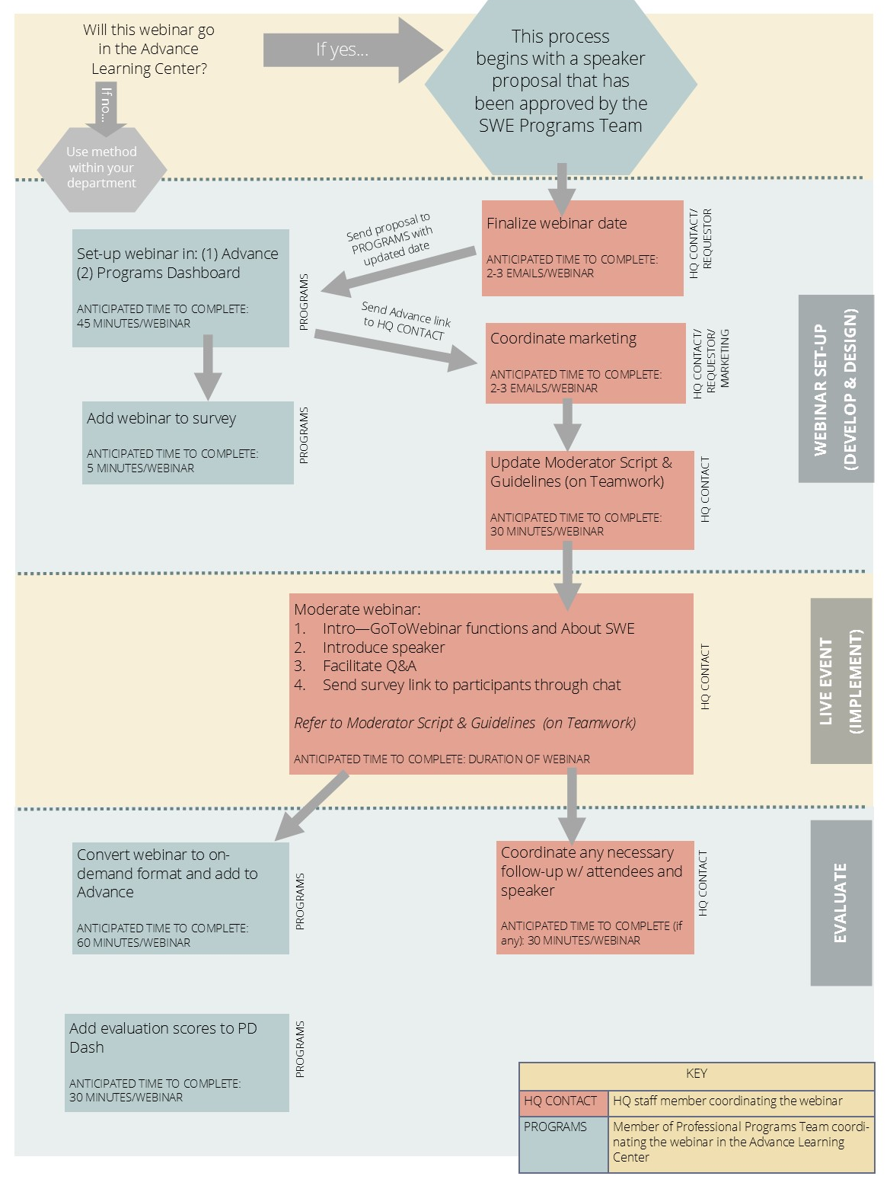
SWE HQ WEBINAR PROCESS:

