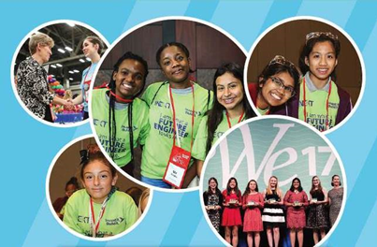
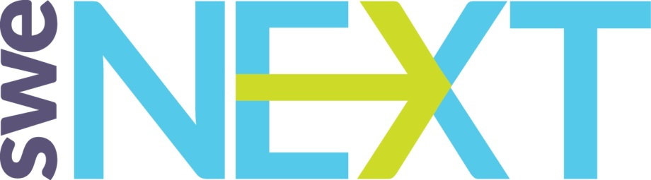

SWENext 101 – A Guide for SWE Members

Welcome

What is SWENext?
- SWENext is a program created and supported by SWE’s K-12 Outreach Committee. It is a way for students who are 18 years old and younger to become a part of the Society of Women Engineers (SWE) community before college. Joining is free.

Who can join SWENext?
- Students ages 13 to 18 can join on their own at any time. For those younger than 13, a parent will need to be the primary contact.
- Families, Educators, and SWE members can be added to the SWENext mailing list as Adult Advocates. They will receive the same emails that SWENexters in their area receive, and have access to the SWENext information and resources.

- What is included in the SWENext Program?
- High School SWENexters receive a monthly newsletter, a monthly advice column (SWEet Wisdom), a monthly social media challenge, scholarship application tips, high school milestones and college prep tips, a closed Facebook group, SWENext awards at annual conference and WE Locals, and access to videos created by SWE collegiate sections highlighting key features of their colleges.
- Kindergarten through 8th grade (K-8) SWENexters receive a monthly newsletter and a monthly at-home engineering activity.
- Both programs include invitations to STEM events hosted by SWE sections, the Society or its partners, access to SWE members, SWENext Swag from the SWEStore, and SWENext Club resources.

- How many SWENexters are there?
- As of June 30, 2018, there were over 3500 SWENexters in the program.

How SWE Members and SWE Sections Can Help

What can SWE Members do to help the SWENext Program?
- SWE members can support the SWENext program by inviting current SWENexters to your STEM Outreach events and by recruiting new SWENexters.
- You could also be a SWENext Club Advisor. (See the SWENext Club Guide for SWE Sections for more information about clubs: http://societyofwomenengineers.swe.org/images/SWENext/SWENext-Club-Guide-for-SWE-Sections.pdf

- How do I invite SWENexters to my STEM events? Can I get a mailing list?
- Because SWENexters are minors, we cannot send you a mailing list. However, we have an easy way for you to invite the SWENexters in your area to your events. Use this form from the K-12 Outreach website: Promote Your Event to SWENexters.
- In addition to the event name, date, time, and location, be ready to supply this information: geographic range of SWENexters who should be invited in terms of miles from event zip code (e.g. 10 miles from zip code 15213) and the school grades of SWENexters the event is for (e.g. 6th, 7th, 8th grades).
- SWE’s Outreach Coordinator will contact SWENexters in your area directly via email to let them know about your upcoming outreach event. She'll also add your event information to the SWE calendar. Allow 2 weeks for processing (so please plan ahead!).

Tip: Want to know if the “Promote Your Event” form worked to encourage SWENexters to attend your event? Add a field on your registration form for where they heard about the event. Consider offering a discounted rate to SWENexters if your event has a fee and provide the code in the email to SWENexters. Finally, you can add a question in your post-event survey to see which of your attendees are SWENexters.

- How else could I use the “Promote Your Event to SWENexters” form?
- You can use the form anytime you want to “talk” directly with SWENexters in your geographic area. For example, high school SWENexters could work as volunteers at your STEM event. Invite them to volunteer using the form. You might want to set up an e-mentoring program between your collegiate section and the local high school SWENexters. Invite them to participate using the form. If your professional section has a Scholarship Program, use the form to tell the local SWENexter seniors how to apply. Always allow 2 weeks for processing.

- How can I find out how many SWENexters are in my area?
- Send a message to swenext@swe.org. Include your zip code, and the name of the professional section nearest you.

Did you know? SWENexters are associated with a local Professional SWE Section based on zip code. SWENexters outside the area of a professional section are classified as Members-at-Large (MALs).

- How can I recruit new SWENexters?

Read about the10 ways you can recruit SWENexters in this document.

- How to talk about SWENext

Below are some scenarios you may encounter at outreach events and some helpful tips to help you talk about SWENext.

Judging at in-person Science Fair
Hand flyer to girl or parent and say: “We loved hearing about your project and hope you pursue engineering in your future. Here is some information about a program where you can join the Society of Women Engineers today for free and have access to things like activities, scholarships, awards, and connections to SWE members. Good luck in the science fair!”

Short Pitch at a booth or outreach event
Hand flyer to girl or parent and say: “Here is some information about a program where you can join the Society of Women Engineers today for free and have access to things like activities, scholarships, awards, and connections to SWE members. We have a laptop here if you’d like to sign up right now. It will only take 2 minutes.”

Speaking to large group at outreach event
Provide flyers in center of tables ahead of the event or in their goodie bags. “We wanted to tell you all about a great program called SWENext that is a way for you to be a part of SWE now for free. The program provides access to scholarships, awards, activities, upcoming SWE events in your area, and connection to SWE members. There is a flyer in <location of flyer> with more information and the SWENext website where you can sign up. Or, if you are ready to sign up right now for free, we have a laptop in the back where you can sign up. We look forward to being a part of your journey to becoming engineers.”
(Note: It is very effective to have a former SWENexter talk about the SWENext program. Since the program has only existed since March 2015, this would likely be a freshman or sophomore in college. Or, if you have a current SWENexter at your event, you could have that person talk about the program.)

SWENext Promotional Resources

- SWE has created free resources to download for your SWENext events. The resources can be found in SWENext Promotional Resources Web Page, and it includes the following items:
- SWENext Logos: Two version of the SWENext logo can be found. A black and white version, and a color version.
- SWENext full page promotional flyers: You are welcome to use the full-page flyer for displays, handouts, or to provide schools to hang in popular areas or hand out to girls. This flyer is full color and contains pictures.
- SWENext half and quarter page flyers: This version was intended to be used as handouts at events like Science Fairs, SWE booths, and at outreach events. There are several versions of the flyer that can be used. The download provides four versions of the mini flyer:
- Color version with choice of 2 per page or 4 per page
- Printer friendly (no pictures) color version, 2 or 4 per page
- Black and white version with choice of 2 per page or 4 per page
- Black and white version (no pictures), 2 or 4 per page
- SWENext Be That Engineer Poster
- SWENext banner and table cloth: SWE has created a SWENext banner and a table cloth template to use at outreaches events. The download provides instructions on how to print the items with your section information included.

Contact Us

- swenext@swe.org: Contact this email address is you have any questions on the SWENext program or if you would like to get involved.
- swenextclubs@swe.org: Contact this email address to find out more information about SWENext Clubs, e.g. to find out how to start a club or to get involved with an existing SWENext Club.
- outreach@swe.org: Contact this email address if you have any general questions for the SWE Outreach Committee.

Help us Measure Our Outreach Impact

Report all of your K-12 Outreach events in the Outreach Metric Tool: here

Visit the Outreach Toolkit where you will find tools to plan, host and measure the success of your event: here

Join the SWE Outreach Incubator Facebook group

Join the conversation about Outreach, share photos, videos, and resources, and ask questions in a larger community of outreach practitioners: here.

